Cluster Partners

Evers International offers worldwide consultancy services for agri- business development in the food security and the water management sector. Public-private approach, market studies, fact-finding missions and seminars are the ingredients of the Uzbek mission. www.eversinternational.eu

Fleuren Boomkwekerij provides added value through its work devising new tree forms and plant systems. Fleuren invented the famous
‘knip-tree’ and ‘3K-tree’, which took the global fruit tree sector to a new level. Recent innovations include large-fruited cherry varieties. Fleuren Boomkwekerij specialises in the cultivation of apple, pear, cherry and plum trees. www.fleuren.net

Verbeek Boomkwekerijen is a specialist supplier of high-quality, virus-free and certified fruit trees. Verbeek offers a large assortment of apple, pear, plum and cherry varieties. Production is at request of any combination of roots, rock and variety. Verbeek Boomkwekerijen actively works with fruit growers all over the world, from the Netherlands and Great Britain to Russia and China. www.verbeek.nu

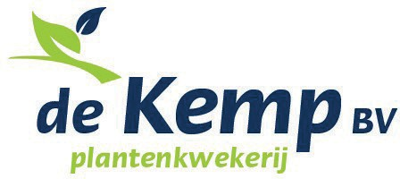
De Kemp BV is a nursery with over 50 years’ experience in growing strawberry plants, asparagus plants, apple rootstocks, pear rootstocks and red currant plants. De Kemp’s goal is to provide the best quality plants for the fruit grower in the right variety. www.dekemp.nl
Fall Creek, a world-leading blueberry breeding and nursery company founded in Oregon (USA) in 1978, serves the global fruit industry by delivering blueberry genetics, plants, variety-specific technical horticultural support and market intelligence to growers. Fall Creek has an established global nursery network with nurseries and R&D centres in the USA, Mexico, Peru, Spain, the Netherlands, and soon South Africa, and licensed distributors in many other countries. Fall Creek offers the industry’s most extensive variety portfolio at all chill levels and is focused on its mission: Building A World With Better Blueberries Through Exceptional Plants, Relationships, Innovation and Customer Success™. www.fallcreeknursery.com

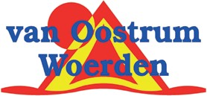
Van Oostrum Woerden is your architect for the design and implementation of your orchard for hard fruit, stone fruit and soft fruit. Based on a GPS survey, Van Oostrum can produce a field survey of the first result. In consultation with the grower, Van Oostrum adds to the exact dimensions of the plot the digital map, determining the ideal layout, which includes the number of rows and trees, the best routing for piping of the drip irrigation or sprinkler and the location of a basin. www.oostrum.biz

VGB Watertechniek has over 30 years’ experience in irrigation and fertigation. VGB offers the latest technological developments in the field of fertigation. VGB is specialised in outdoor drip and sprinkler irrigation (night frost protection) and hard fruit, stone fruit and soft fruit orchards and plantations. www.vgbwatertechniek.nl/

Fruit Security Holland has vast amounts of experience in designing, building and maintaining hail nets and foil covering in orchards. Fruit Security Holland has many years of experience in protecting fruit trees, plants and shrubs. Its clients are growers, nurseries and even fleet operators. FSH has built a large number of shelters all over Europe and distributes products worldwide. www.fruitsecurityholland.com
Delphy stands for worldwide expertise for food & flowers. Delphy’s expertise can be found in modern fruit cultivation with a focus on digitalisation of the fruit cultivation. The possibilities with weather, soil and crop data bring the consultancy to a total Quality Management System (QMS). High density orchards, irrigation management etc. are the Delphy consultants’ main questions. www.delphy.nl

Koppert Biological Systems produces sustainable cultivation solutions for food crops and ornamental plants. Together with growers and in partnership with nature, Koppert works to make agriculture and horticulture healthier, safer, more productive and resilient. It achieves this by employing natural enemies to combat pest infestations, bumblebees for natural pollination and bio-stimulants that support and strengthen the crops both above and underground. www.koppert.nl

Geerlofs Refrigeration is a leading specialist in cold storage solutions for fresh and frozen produce. Geerlofs combines knowledge of fresh produce with engineering expertise. Geerlofs has more than 85 years’ experience in designing and building turn-key cold storage worldwide for agriculture products, flowers and flower bulbs, the food processing industry and perishables centres. www.geerlofs.com

Aweta G&P BV is a producer of grading and packing solutions for all types of fruits. Their grading machines are tailor-made to the specific capacity and packing requirements of the customer. The machines range from small standalone machines to completely integrated grading and packing solutions for apples, pears and stone fruits.
www.aweta.nl

Collaborating partner

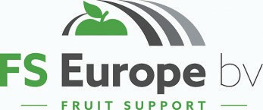
FS Europe has many years’ experience in the field of orchard protection. FS Europe offers solutions that work more efficiently and deliver a real quality end product. FS Europe is specialised in supplying a complete package of support and covering materials across Europe with a broad distribution of products worldwide. www.fseurope.eu
Let’s cooperate!
Cluster coordinator Alfred Evers
Evers International
The Netherlands T: +31 6 5495 6148
E: info@eversinternational.eu
Liaison
Furkat Alimukhamedov
Tashkent, Uzbekistan
T: +998 97 701 75 30
E: furkatuzte@gmail.com
E: FurkatAlimukhamedov <furkatuzte@gmail.com>
Embassy
Kalashny Pereulok 6|115127| Moscow |Russia,
E: mos-lnv@minbuza.nl

Dutch Fruit Solutions Uzbekistan
Growing a sustainable fruit sector together
Hol Spraying Systems has been a manufacturer of fruit crop protection machinery since 2010. Hol’s developed focus points are maximum deposition and less drift reduction, combined in an easy machine that gives growers a useful product. In its range, Hol builds single and triple row orchard sprayers, with different versions of weed sprayers and chemical mixers. www.holsprayingsystems.com

Liaison
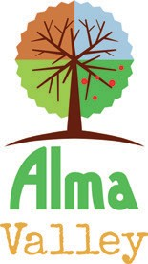
BVB Substrates is the specialist in substrates for the soft fruit sector. They offer substrates for several different types of soft fruits, such as blueberries, strawberries, raspberries and blackberries. With its own R&D Department, technically advanced laboratories and a phytotron BVB Substrates believes in a true focus on customer success. www.bvb-substrates.nl

.

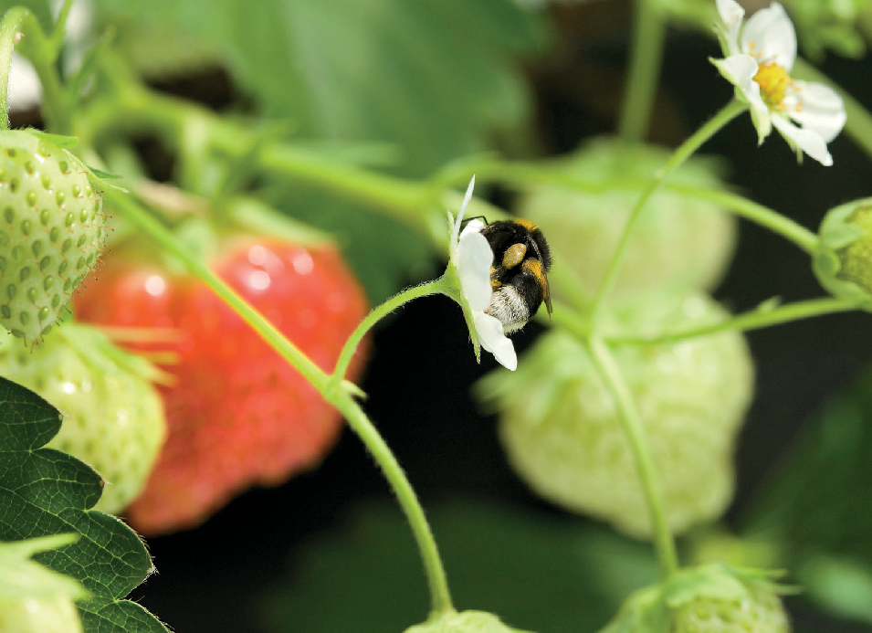

The government of Uzbekistan has very ambitious agricultural programmes. Their aim is to develop the fruit sector into a modern sector with large-scale & high density plantations, revitalise fruit cultivation (50%) and plant new (50%) with high-yielding starting material and associated cultivation techniques. Modernisation goes hand in hand with a high demand for new fruit varieties, modern machineries and equipment, advanced technologies and industrial expertise.

New large fruit orchards cannot only supply the domestic market, but excess fruit can also be exported abroad. The demand for fruit in Russia and China has increased, and the Uzbek fruit sector is ideally positioned to take advantage of this.

As a result of the existing Cooperation Protocol between the Netherlands and Uzbekistan (2018), the Netherlands is a strategic partner for Uzbekistan. Our horticulture sector is well-known abroad, and it is an important contributor to the Dutch economy. Dutch fruit meets the global demand for healthy food for millions of people around the world. Our expertise and innovation allow us to produce and export fruit to every continent. We grow fruit in soil and greenhouses, using the most advanced and sustainable techniques.

This is why the government of the Netherlands and a group of companies representing the Dutch fruit sector have developed a public-private partnership, Dutch Fruit Solutions Uzbekistan (DFSU), to assist Uzbekistan in making the fruit sector more efficient, profitable and sustainable.

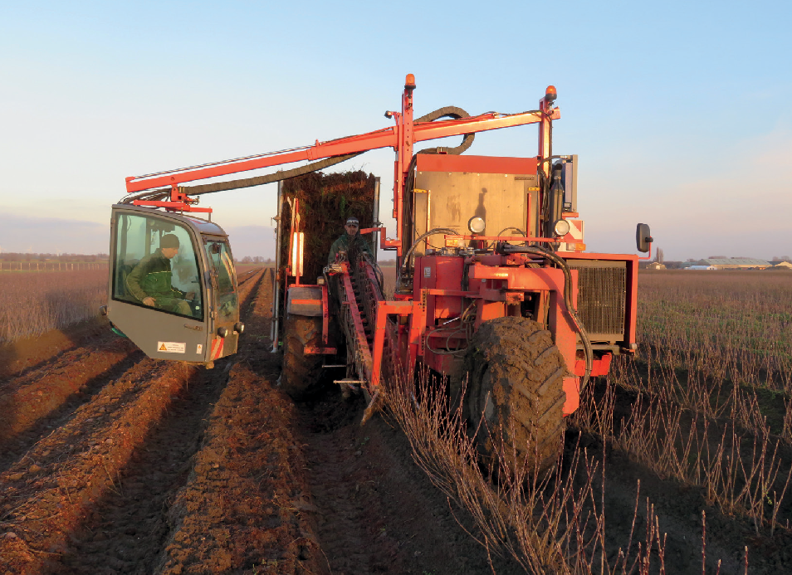
The Uzbek authorities have ambitious plans for the fruit sector, and DFSU is there to support them. Together, we will improve the production of hard fruit, soft fruit and stone fruit. We aim to contribute to fruit quality, fruit quantity, fruit protection and fruit export through:

- Virus-free planting materials;
- Design and implementation of (super) intensive orchards;
- Optimisation of pre-harvest, harvest and post-harvest activities.

We provide our integrated Dutch approach of fruit production and processing, adjusted to local Uzbek requirements. We aim to to cooperate with local and national governments, knowledge centres and companies in the fruit sector.

What are we planning to do?
- Dedicated liaison officer in Uzbekistan
- Invite stakeholders to the demo plot - a high-tech orchard in Talgar, Kazakhstan
- Transfer knowledge needed to achieve higher levels of efficiency, quality and sustainability
- Participation agricultural fair in Tashkent
- Organise roadshows, seminars, and round tables in fruit production areas
- Visit by Uzbek stakeholders to the Netherlands

An integrated approach for a profitable fruit sector

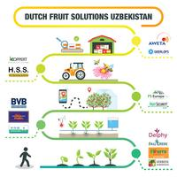

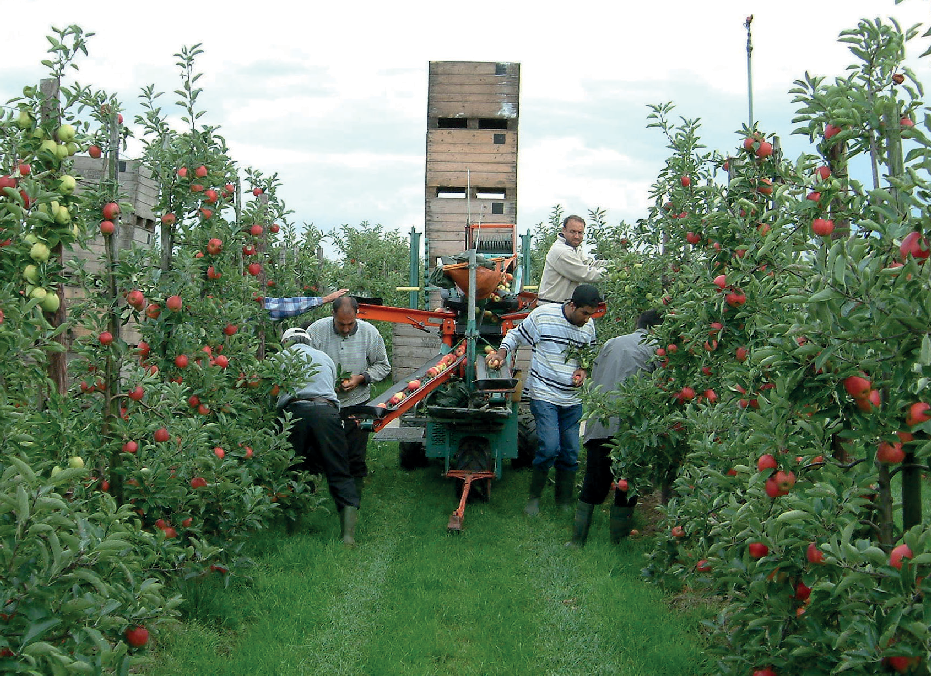
A fruitful partnership for sustainable economic growth
The public-private partnership Dutch Fruit Solutions Uzbekistan (DFSU) is a collaboration between the Dutch Ministry of Foreign Affairs, the Dutch Ministry of Economic Affairs and Climate, the Netherlands Embassy in Kazakhstan, the Netherlands honorary consulate in Tashkent, the Netherlands Embassy in Moscow, the Netherlands Enterprise Agency (RVO) and fifteen representatives of the Dutch fruit sector. To assist the Uzbek sector in developing the economy in general and the fruit sector in particular, the Dutch government supports this public-private cooperation.

DFSU provides state-of-the-art planting materials and post-harvest handling, storage and processing technologies and facilitation of transportation, as well as adaption of tailor- made and chain-wide solutions to improve productivity, food safety and quality of fruit production.

DFSU aims to contribute to a more sustainable and highly efficient fruit sector, which boosts sustained economic growth and encourages technological innovation. Local communities will benefit from a more competitive fruit sector through job and income generation.

